Graphic Exercises
1. Use arrays and repetition statements to draw a rainbow by using Graphics method fillArc

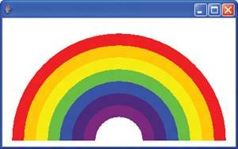

These are import statements for creating drawings

import java.awt.Color;
import java.awt.Graphics;
import javax.swing.JPanel;

Color VIOLET = new Color( 128, 0, 128 );
Color INDIGO = new Color( 75, 0, 130 );

// colors to use in the rainbow, starting from the innermost
// The two white entries result in an empty arc in the center

Color colors[] = { Color.WHITE, Color.WHITE, VIOLET, INDIGO, Color.BLUE, Color.GREEN, Color.YELLOW, Color.ORANGE, Color.RED };

This is declare and create two new colors VIOLET and INDIGO . As you may know, the colors of a rainbow are red, orange, yellow, green, blue, indigo and violet. Java only has predefined constants for the first five colors. Next lines initialize an array with the colors of the rainbow, starting with the innermost arcs first. The array begins with two Color.WHITE elements, which, as you will soon see, are for drawing the empty arcs at the center of the rainbow.
// draw the rainbow near the bottom-center
int centerX = getWidth() / 2; // or this. getWidth()
int centerY = getHeight() - 10; // or this. getHeight()

2. Try to draw this, using loops and drawLine.
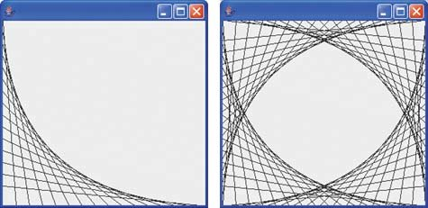
3. Drawing Spirals (BONUS)
In this exercise, you will draw spirals with methods drawLine and drawArc.(pick one a or b)
- Draw a square-shaped spiral , centered on the panel, using method drawLine . One technique is to use a loop that increases the line length after drawing every second line. The direction in which to draw the next line should follow a distinct pattern, such as down, left, up, right.

Drawing a spiral using drawLine (left) and drawArc (right).
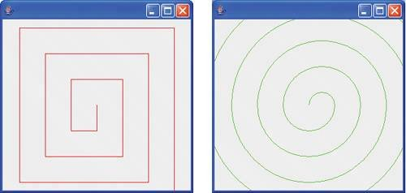
- Draw a circular spiral using method drawArc to draw one semicircle at a time. Each successive semicircle should have a larger radius (as specified by the bounding rectangle's width) and should continue drawing where the previous semicircle finished.

